

|  |  |  |  |  |  |  |  |  |  |  |  |  |  |  |  |  |  |  |  |  |  |  |  |  |  |  |  |  |  |  |  |  |  |  |  |  |  |  |  |  |  |  |  |  |  |  |  |  |  |  |  |  |  |  |  |  |  |  |  |  |  |  |  |  |  |  |  |  |  |  |  |  |  |  |  |  |  |  |  |  |  |  |  |  |  |  |  |  |  |  |  |  |  |  |  |  |  |  |  |  |  |  |  |  |  |  |  |  |  |  |  |  |  |  |  |  |  |  |  |  |  |  |  |  |  |  |  |  |  |  |  |  |  |  |  |  |  |  |  |  |  |  |  |  |  |  |  |  |  |  |  |  |  |  |  |  |  |  |  |  |  |  |  |  |  |  |  |  |  |  |  |  |  |  |  |  |  |
| --- | --- | --- | --- | --- | --- | --- | --- | --- | --- | --- | --- | --- | --- | --- | --- | --- | --- | --- | --- | --- | --- | --- | --- | --- | --- | --- | --- | --- | --- | --- | --- | --- | --- | --- | --- | --- | --- | --- | --- | --- | --- | --- | --- | --- | --- | --- | --- | --- | --- | --- | --- | --- | --- | --- | --- | --- | --- | --- | --- | --- | --- | --- | --- | --- | --- | --- | --- | --- | --- | --- | --- | --- | --- | --- | --- | --- | --- | --- | --- | --- | --- | --- | --- | --- | --- | --- | --- | --- | --- | --- | --- | --- | --- | --- | --- | --- | --- | --- | --- | --- | --- | --- | --- | --- | --- | --- | --- | --- | --- | --- | --- | --- | --- | --- | --- | --- | --- | --- | --- | --- | --- | --- | --- | --- | --- | --- | --- | --- | --- | --- | --- | --- | --- | --- | --- | --- | --- | --- | --- | --- | --- | --- | --- | --- | --- | --- | --- | --- | --- | --- | --- | --- | --- | --- | --- | --- | --- | --- | --- | --- | --- | --- | --- | --- | --- | --- | --- | --- | --- | --- | --- | --- | --- | --- | --- | --- | --- |
| |  |  |  |  |  |  |  | | --- | --- | --- | --- | --- | --- | --- | | ENERO | | | | | | | | **D** | **L** | **M** | **M** | **J** | **V** | **S** | |  |  | **1** | 2 | 3 | 4 | 5 | | **6** | 7 | 8 | 9 | 10 | 11 | 12 | | **13** | 14 | 15 | 16 | 17 | 18 | 19 | | **20** | 21 | 22 | 23 | 24 | 25 | 26 | | **27** | 28 | 29 | 30 | 31 |  |  | |  | | | | | | | | |  |  |  |  |  |  |  | | --- | --- | --- | --- | --- | --- | --- | | FEBRERO | | | | | | | | **D** | **L** | **M** | **M** | **J** | **V** | **S** | |  |  |  |  |  | 1 | 2 | | **3** | 4 | 5 | 6 | 7 | 8 | 9 | | **10** | **11** | 12 | 13 | 14 | 15 | 16 | | **17** | 18 | 19 | 20 | 21 | 22 | 23 | | **24** | 25 | 26 | 27 | 28 |  |  | |  | | | | | | | |  | | | | | | | | |  |  |  |  |  |  |  | | --- | --- | --- | --- | --- | --- | --- | | MARZO | | | | | | | | **D** | **L** | **M** | **M** | **J** | **V** | **S** | |  |  |  |  |  | 1 | 2 | | **3** | **4** | **5** | 6 | 7 | 8 | 9 | | **10** | 11 | 12 | 13 | 14 | 15 | 16 | | **17** | 18 | 19 | 20 | 21 | 22 | 23 | | **24/31** | 25 | 26 | 27 | 28 | 29 | 30 | |  | | | | | | | |
| |  |  |  |  |  |  |  | | --- | --- | --- | --- | --- | --- | --- | | ABRIL | | | | | | | | **D** | **L** | **M** | **M** | **J** | **V** | **S** | |  | 1 | **2** | 3 | 4 | 5 | 6 | | **7** | 8 | 9 | 10 | 11 | 12 | 13 | | **14** | 15 | 16 | 17 | **18** | **19** | 20 | | **21** | 22 | 23 | 24 | 25 | 26 | 27 | | **28** | 28 | 30 |  |  |  |  | |  | | | | | | | | |  |  |  |  |  |  |  | | --- | --- | --- | --- | --- | --- | --- | | MAYO | | | | | | | | **D** | **L** | **M** | **M** | **J** | **V** | **S** | |  |  |  | **1** | 2 | **3** | 4 | | **5** | 6 | 7 | 8 | 9 | **10** | 11 | | **12** | 13 | 14 | 15 | 16 | 17 | 18 | | **19** | 20 | 21 | 22 | 23 | 24 | **25** | | **26** | 27 | 28 | 29 | 30 | 31 |  | |  | | | | | | | | |  |  |  |  |  |  |  | | --- | --- | --- | --- | --- | --- | --- | | JUNIO | | | | | | | | **D** | **L** | **M** | **M** | **J** | **V** | **S** | |  |  |  |  |  |  | 1 | | **2** | 3 | 4 | 5 | 6 | 7 | 8 | | **9** | 10 | 11 | 12 | 13 | 14 | 15 | | **16** | **17** | 18 | 19 | **20** | 21 | 22 | | **23/30** | 24 | 25 | 26 | 27 | 28 | 29 | |  | | | | | | | |
| |  |  |  |  |  |  |  | | --- | --- | --- | --- | --- | --- | --- | | JULIO | | | | | | | | **D** | **L** | **M** | **M** | **J** | **V** | **S** | |  | 1 | 2 | 3 | 4 | 5 | 6 | | **7** | **8** | **9** | 10 | 11 | 12 | 13 | | **14** | 15 | 16 | 17 | 18 | 19 | 20 | | **21** | 22 | 23 | 24 | 25 | 26 | 27 | | **28** | 29 | 30 | 31 |  |  |  | |  | | | | | | | | |  |  |  |  |  |  |  | | --- | --- | --- | --- | --- | --- | --- | | AGOSTO | | | | | | | | **D** | **L** | **M** | **M** | **J** | **V** | **S** | |  |  |  |  | 1 | 2 | 3 | | **4** | 5 | 6 | 7 | 8 | 9 | 10 | | **11** | 12 | 13 | 14 | 15 | 16 | **17** | | **18** | **19** | 20 | 21 | 22 | 23 | 24 | | **25** | 26 | 27 | 28 | 29 | 30 | 31 | |  | | | | | | | | |  |  |  |  |  |  |  | | --- | --- | --- | --- | --- | --- | --- | | SEPTIEMBRE | | | | | | | | **D** | **L** | **M** | **M** | **J** | **V** | **S** | | **1** | 2 | 3 | 4 | 5 | 6 | 7 | | **8** | 9 | 10 | 11 | 12 | 13 | 14 | | **15** | 16 | 17 | 18 | 19 | 20 | 21 | | **22** | 23 | 24 | 25 | 26 | 27 | 28 | | **29** | 30 |  |  |  |  |  | |  | | | | | | | |
| |  |  |  |  |  |  |  | | --- | --- | --- | --- | --- | --- | --- | | OCTUBRE | | | | | | | | **D** | **L** | **M** | **M** | **J** | **V** | **S** | |  |  | 1 | 2 | 3 | 4 | 5 | | **6** | 7 | 8 | 9 | 10 | 11 | **12** | | **13** | **14** | 15 | 16 | 17 | 18 | 19 | | **20** | 21 | 22 | 23 | 24 | 25 | 26 | | **27** | 28 | 29 | 30 | 31 |  |  | |  | | | | | | | | |  |  |  |  |  |  |  | | --- | --- | --- | --- | --- | --- | --- | | NOVIEMBRE | | | | | | | | **D** | **L** | **M** | **M** | **J** | **V** | **S** | |  |  |  |  |  | 1 | 2 | | **3** | 4 | 5 | 6 | 7 | 8 | 9 | | **10** | 11 | 12 | 13 | 14 | 15 | 16 | | **17** | **18** | 19 | 20 | 21 | 22 | 23 | | **24** | 25 | 26 | 27 | 28 | 29 | 30 | |  | | | | | | | | |  |  |  |  |  |  |  | | --- | --- | --- | --- | --- | --- | --- | | DICIEMBRE | | | | | | | | **D** | **L** | **M** | **M** | **J** | **V** | **S** | | **1** | 2 | 3 | 4 | 5 | 6 | 7 | | **8** | 9 | 10 | 11 | 12 | 13 | 14 | | **15** | 16 | 17 | 18 | 19 | 20 | 21 | | **22** | 23 | **24** | **25** | 26 | **27** | 28 | | **29** | 30 | 31 |  |  |  |  | |  | | | | | | | |

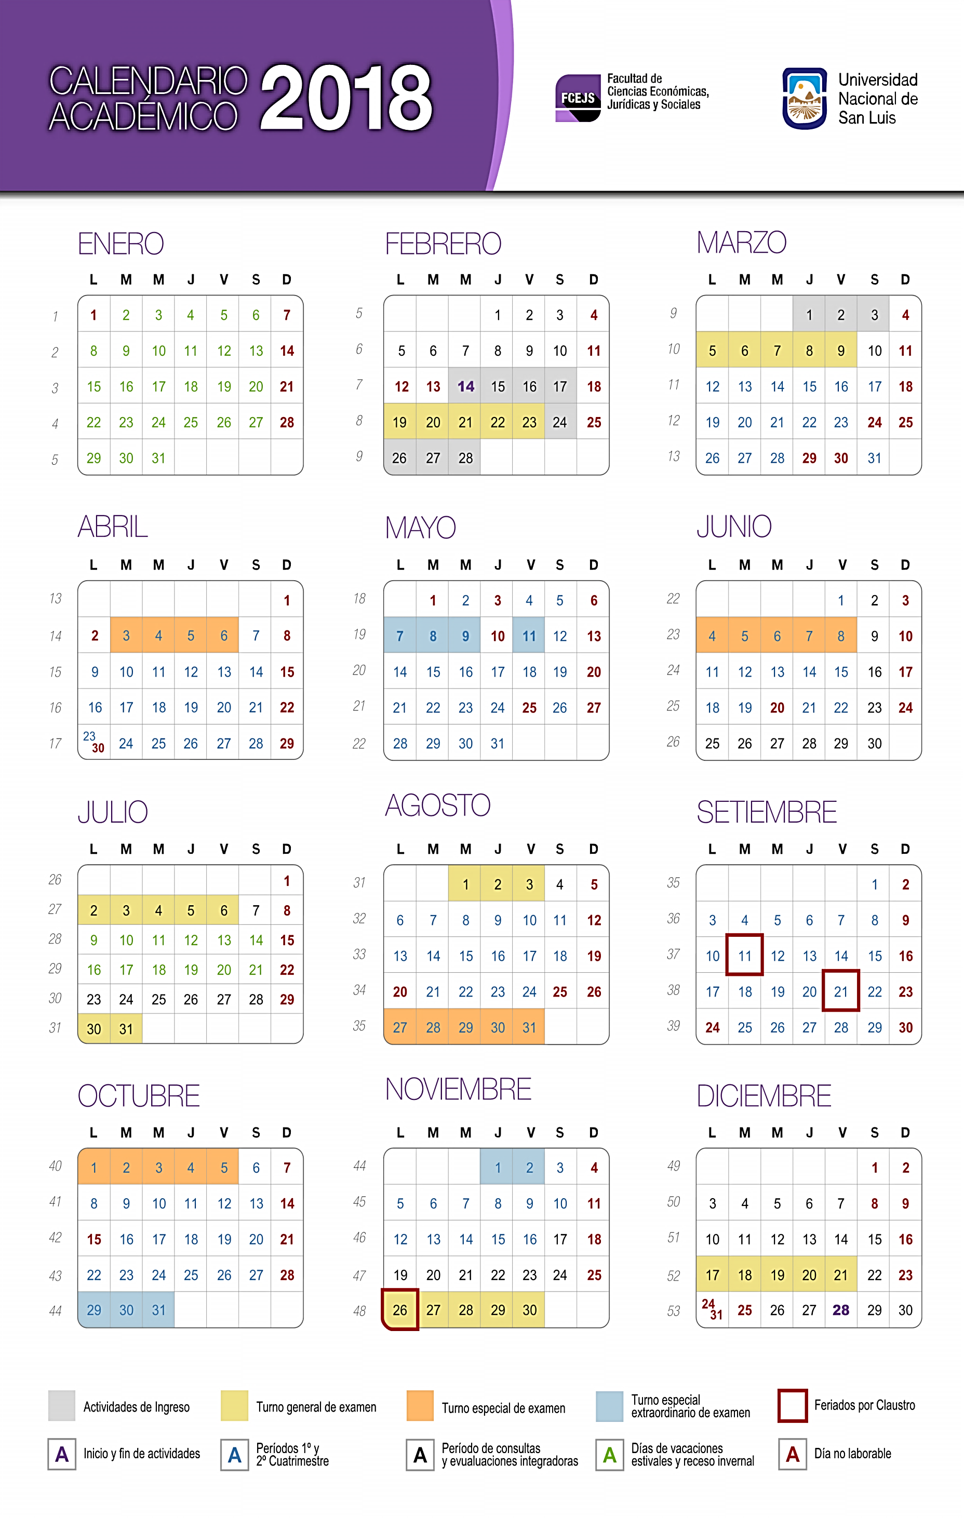

A